**SORTING ALGORITHMS**

SELECTION SORT

OUTPUT:

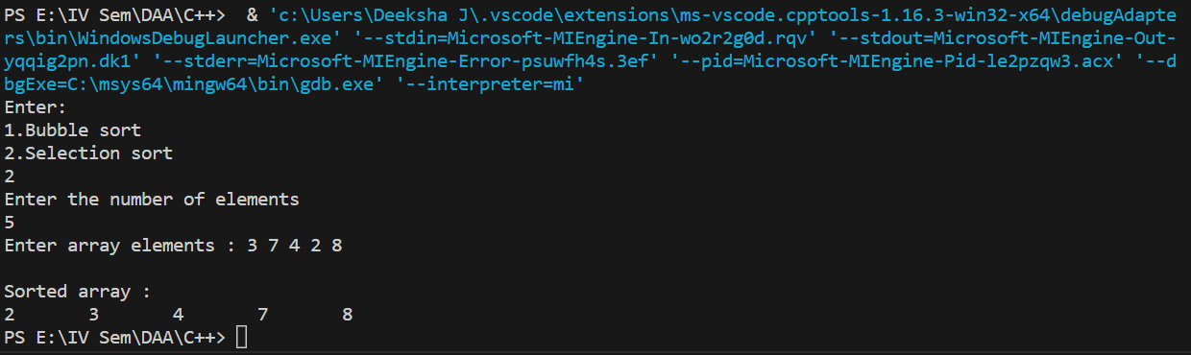

BUBBLE SORT

OUTPUT:

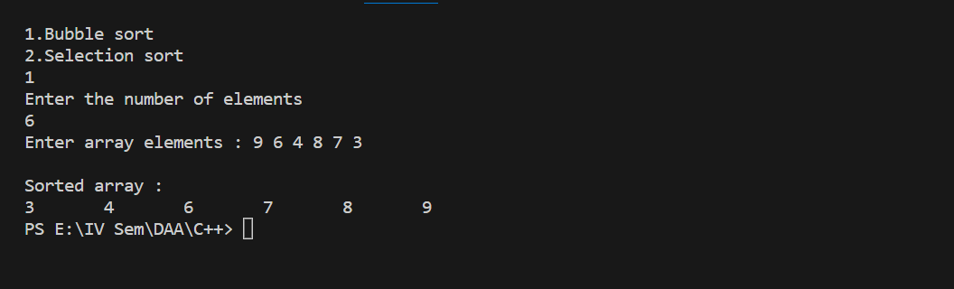

|  |  |  |
| --- | --- | --- |
| n | Bubble sort count | Selection sort count |
| 100 | 4950 | 4950 |
| 200 | 19900 | 19900 |
| 300 | 44850 | 44850 |
| 400 | 79800 | 79800 |
| 500 | 124750 | 124750 |

MERGE SORT

OUTPUT:

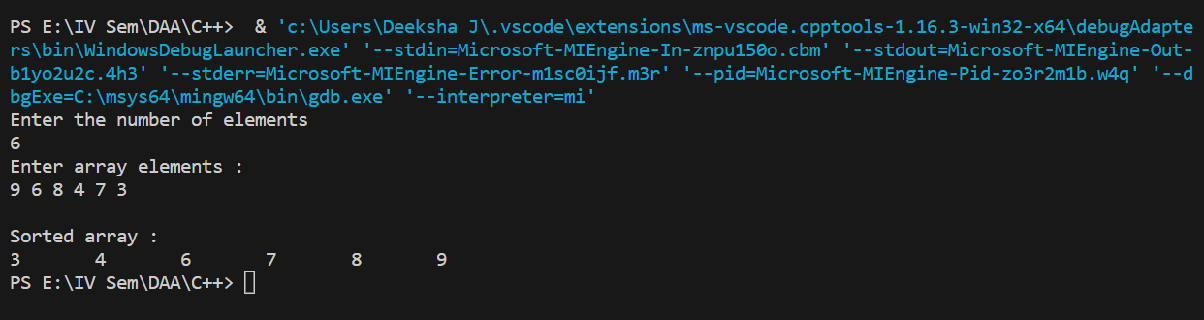

QUICK SORT

OUTPUT:

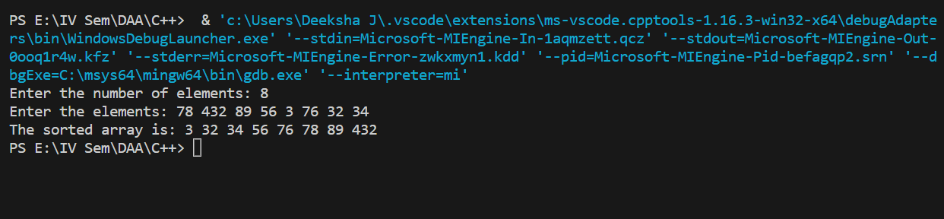

|  |  |  |
| --- | --- | --- |
| n | Merge Sort count | Quick sort count |
| 4 | 7 | 5 |
| 6 | 11 | 9 |
| 8 | 15 | 13 |
| 10 | 19 | 13 |